**Open Source Lab Assignment**

**Shivam Chauhan**

**9917103026**

Q1. Create a python script to print hello, world! four times.



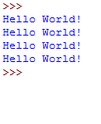

Q3. Write a function “duplicate” to find all duplicates in the list.

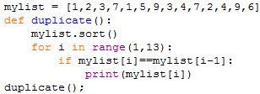



Q4. Write a function group (list, size) that take a list and splits into smaller lists of given size.

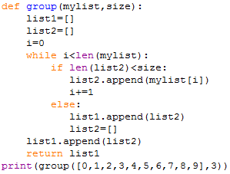



Q5. Write a function “lensort” to sort a list of strings based on length.

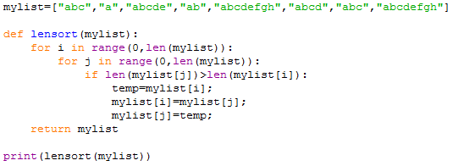



Q6. Write a function extsort to sort a list of files based on extension.

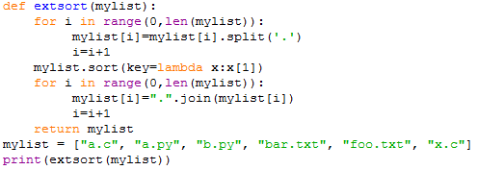



Q7. Use Python Built-in Functions ‘open’, ‘read’, ‘’readline, ‘write’,’writeline’ to work with files.

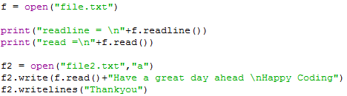

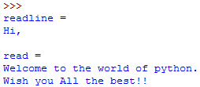

Q8. Compute the number of characters, words and lines in a file.

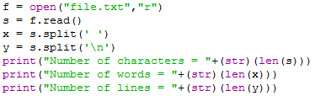



Q9. Write a program reverse.py to print lines of a file in reverse order.

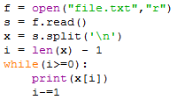



Q10. Write a program to print each line of a file in reverse order.

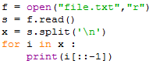

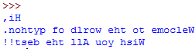

Q11. Write a program wrap.py that takes filename and width as aruguments and wraps the lines longer than width.

